**Student number / name:** 21382104 / Italo Gomes Santana

**Introduction**

I will present in this document ten scenarios that I judged the main ones for the stakeholders. Through the provided data, Medicare and Australian Government can now have the results about the implemented plans between 2006 and 2011. Also, they are able to design new strategies for the next years. Regarding the scenarios showed in this document, these new strategies can be made easier.

The data warehouse schema suggested for this project is present in the final of the document as well as final comments.

**CASE #1**

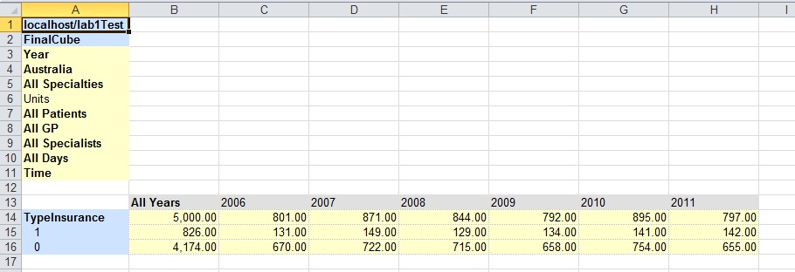

I treated the value 1 as a ‘Yes’ when the health system user has a private insurance (16.52%). Otherwise, the value 0 means the user is fully dependent on the public health system (83.48%). Therefore, this result means that the government should be aware about the health system, mainly regarding treatments for fully dependents. They represent over 3 quarters of the whole health system.

**CASE #2**

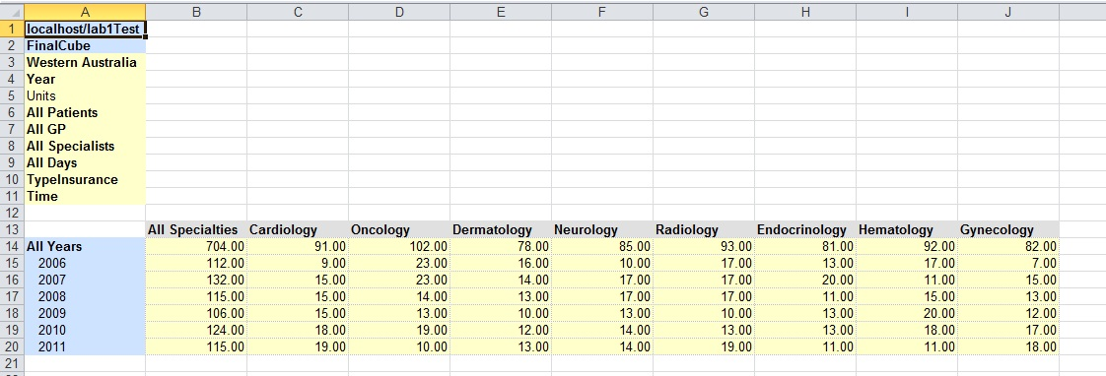

This case shows that in Western Australia, the numbers of cardiology problems had risen gradually along the years. It indicates that the government should change its campaign to prevent cardiology problems from now on, mainly those related with Pediatric Tachycardia that suffered a little outbreak in 2011(see detailed table below).

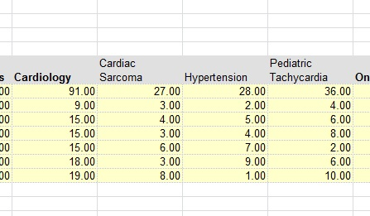

**CASE #3**

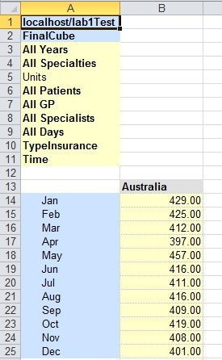

The case #3 shows that the number of appointments remains steady. In addition, the table illustrates that between April and May exist a big gap that it is meaningful. Assuming that the ticket prices to travel overseas are cheap due to low season (mainly in April and May), people are likely to suffer diseases from their destinations. So, the government could improve its strategies to handle with people that transited in these countries.

**CASE #4**

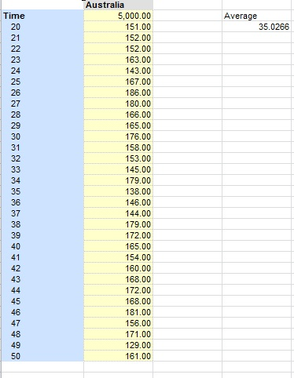

The appointment time assumed here is between 10 and 50 minutes. The average of the duration of this is 35 minutes. Assuming that 30 minutes is the minimum for each appointment, the results are quite accurate to the goal proposed by the government.

**CASE #5**

These values are related with the total cost of the treatments of each appointment. As it is showed, the state that the government had spent much money is Queensland.

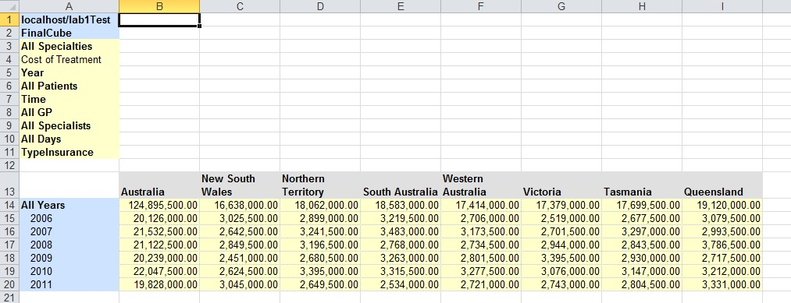

The picture below shows the costs related with all specialties and the states. It can guide the government to search new changes and reduce costs of treatments, mainly about Hematology(most expensive).

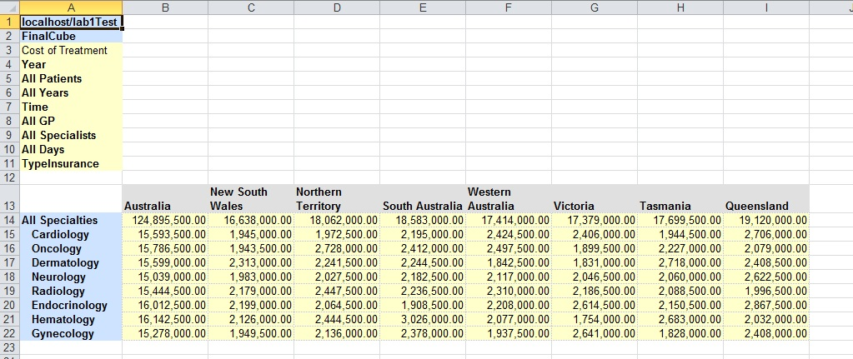

**CASE #6**

This case shows the pharmaceutical benefit provided by the government and how it impacts in each state. Again, Queensland holds the highest amount of pharmaceutical benefit in all years. The limit of the pharmaceutical benefit for each patient is up to $500, the amount of money over the limit is paid by the patient. If the budget available for the pharmaceutical benefit is too high to the government afford, then the government should review its pharmaceutical benefits policies.

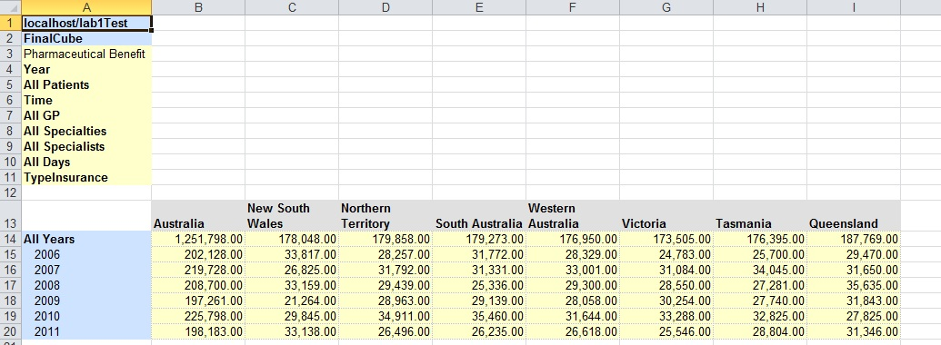

**CASE #7**

This case shows the quantity of days that the user should wait for the specialist. Therefore, considering the data showed below, it is a severe situation to the government deal with. It should take decisions as soon as possible to solve the problem of the queue’s length.

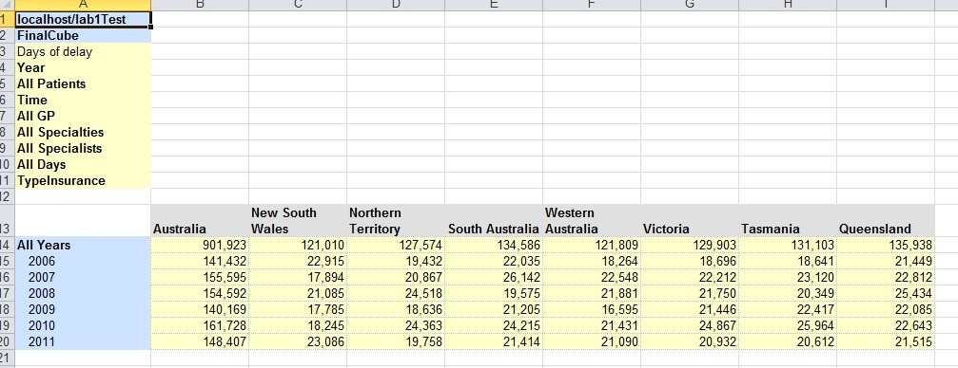

**CASE #8**

This table below shows the costs of the treatment according to the quarters of the year. The trend here is that the government spends more money in the first half of the year than the second half. So, it should be prepared to create new plans to optimize its costs.

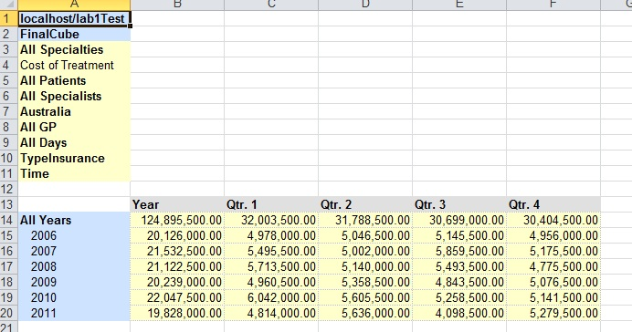

**CASE #9**

This table below shows that along the years, the 4th  and 2th quarters have been increased by the number of the days of delay. Therefore, the medicare should be prepared to take decisions to prevent possible issues in these periods of the years from now on.

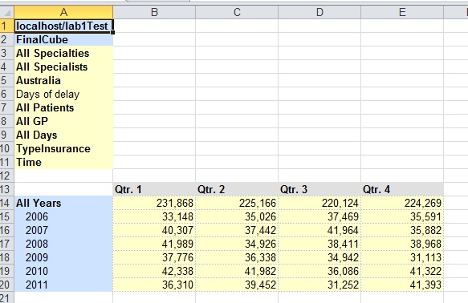

**CASE #10**

Analyzing the table below, it shows that Neurology and Hematology had a little outbreak in the last year (2011). The others specialties kept approximately the same value during the years. It shows that the demand for these two areas is increasing and they will represent a big cost to the government for the future.

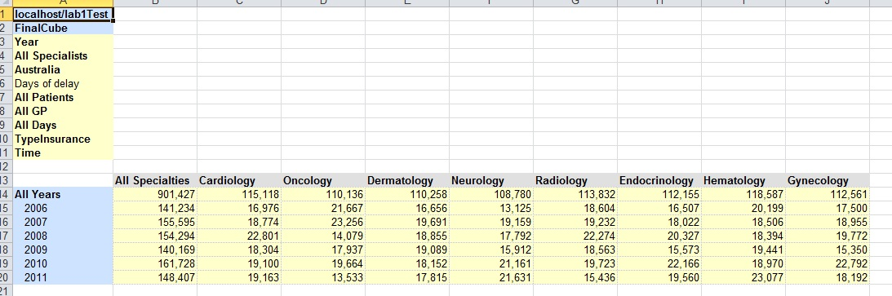

**DATA WAREHOUSE SCHEMA**

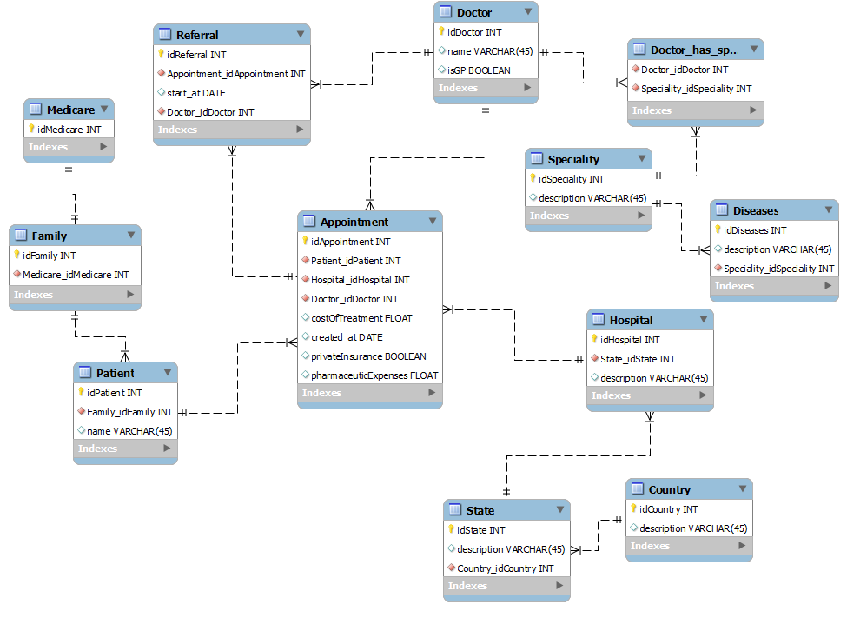

This schema shows nearly the data warehouse that best represents this project.

**FINAL COMMENTS**

Although the data presented in this project are totally random, the showed results trends and behaviors that are easily observed by using the Palo. The cube has been posted below and it shows the dimensions that I have created.

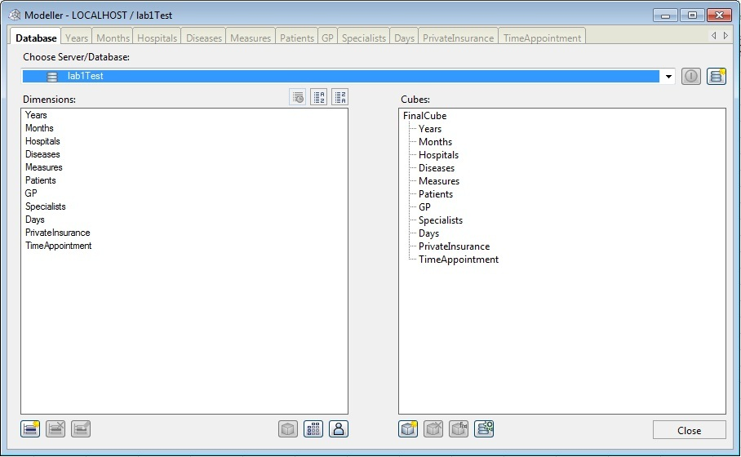

**Student number / name:** 21382104 / Italo Gomes Santana